Hong Kong Institute of Vocational Education
IT114105 HD in Software Engineering
ITP4514 Artificial Intelligence and Machine Learning

Lab 2 – Collection Data Types, NumPy and Pandas

Exercise 1
Write a Python program to generate an array to contain Mark Six values which are randomly generate 6 values within the range 1 to 49.

Example:

Please note that in your program, you are NOT allowed to use nested loop to solve duplicate values problem.

Exercise 2
Write a Python program which can handle some basic functions for all the card games such as Blackjack or Poker.
Your program needs to build a Deck with 52 cards, each card Each card has a suit and a number.
Suit: Spade, Heart, Club, Diamond
Number: Ace, 02, 03, ... 10, Jack, Queen, King
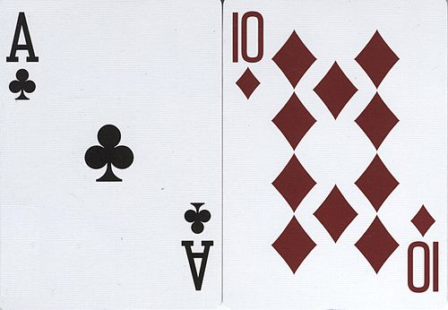

And then your program needs to ask how many players and how many cards for one player. Your program randomly to draw cards from the deck and then assign to each player. Finally, your program shows each player's hand.
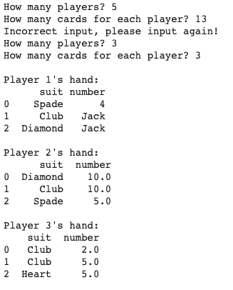

*** End of Lab 2 ***

